CSE 204

Data Structure & Algorithms 1

A Runtime Comparison Between Insertion and Selection Sort in Arrays

Submitted By

A.Z.M Mehedi Hasan

S201705035

Submitted to

Shareef Ahmed

Mehnaz tabassum Mahin

Submission Date : 9th June, 2019

Complexity Analysis for Insertion Sort :

Insertion sort runs in O(n)  time in its best case and runs in O(n2) in its worst and average cases.

Best Case:

Insertion sort performs two operations: it scans through the list, comparing each pair of elements, and it swaps elements if they are out of order. Each operation contributes to the running time of the algorithm. If the input array is already in sorted order, insertion sort compares O(n)  elements and performs no swaps .Therefore, in the best case, insertion sort runs in O(n)  time.

Worst Case and Average Case:

The worst case will appear when the array is sorted in reversed way. And the complexity is O(n2). The average case has the same complexity.

Complexity for Selection Sort:

Selection sort has the same complexity in its all three cases. The complexity is O(n2).

Machine configuration:

Manufacturer : ASUSTek Computer Inc.

Processor : Intel Core i7 – 8th Gen

Ram : 8 GB

System Type : 64 bit operating Sytem

Platform used: CodeBlocks IDE is used to run the codes in C++17. The fetched data about runtime was plotted using Microsoft Exel.

Insertion Sort Graph :

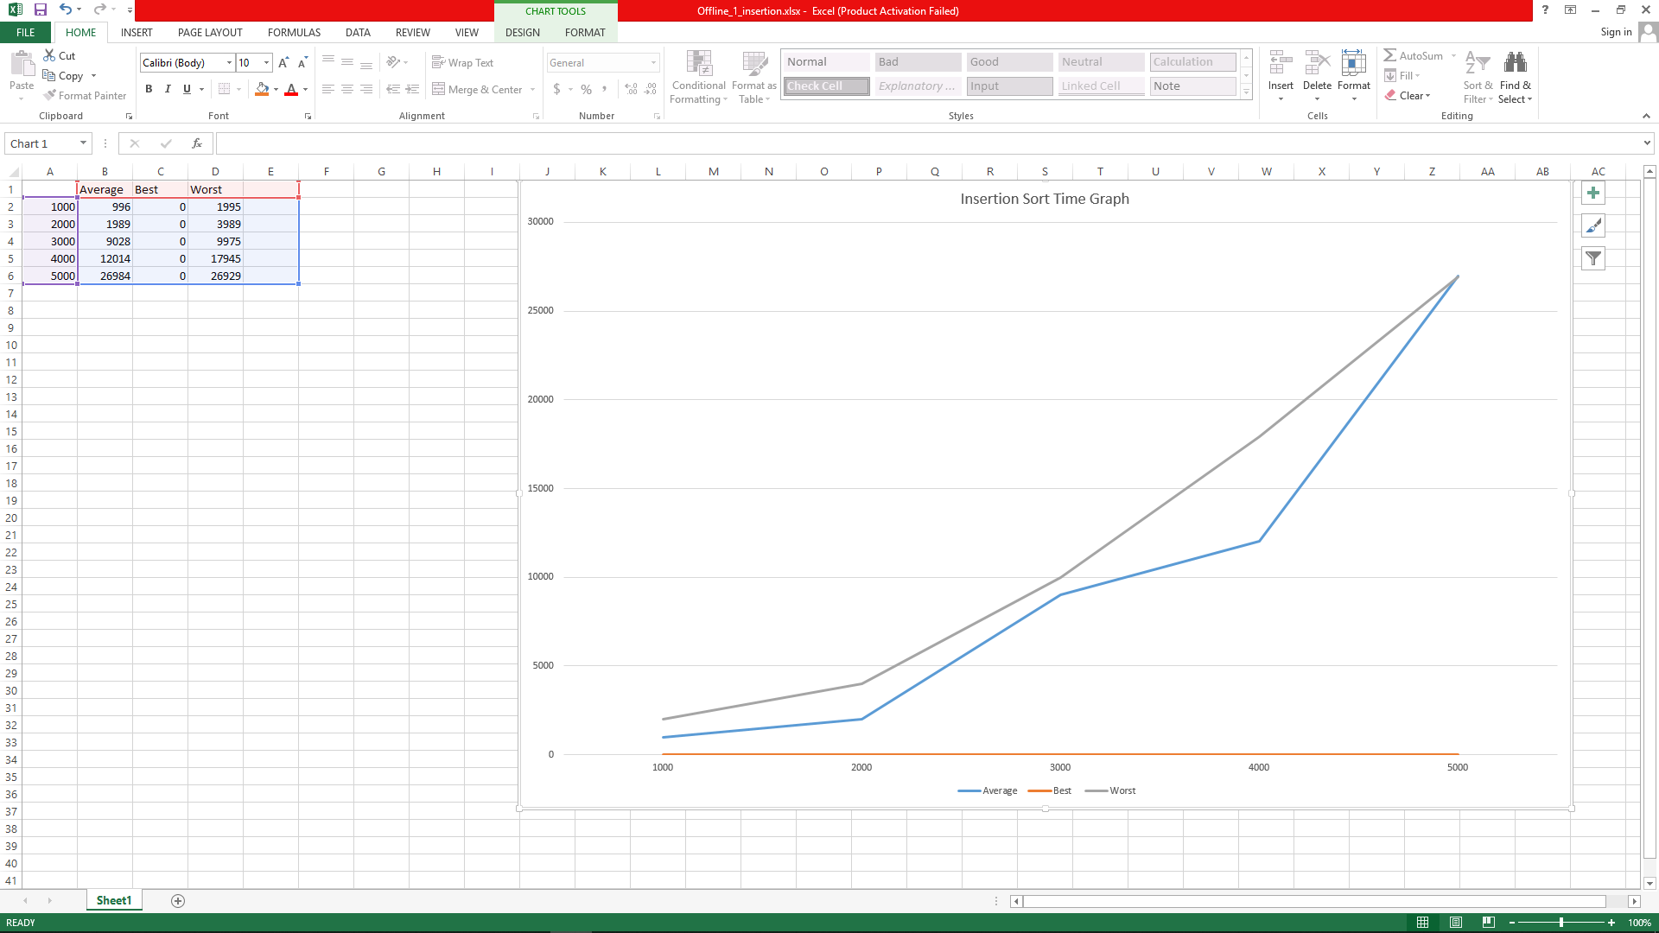

Selection Sort Graph :

